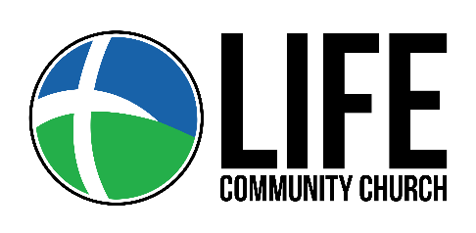

Dear Life Community Family, Attenders & Guest,

Truly my soul silently waits for God; From Him comes my salvation. He only is my rock and my salvation; He is my defense; I shall not be greatly moved. Psalm 62:1-2

Effective this Sunday, March 22, 2020 in accordance with guidelines set forth by the President and Governor, we will not gather publicly. Instead we invite you to join us on Facebook Live or YouTube Live. Please subscribe to get notifications from both when we go live for Prayer, Bible Study, Online Gathering and other unique ways we have planned to keep you connected, encouraged and equipped.
Pastor Tracie and I, along with the Intercessory team will be praying for you. If you find yourself feeling lonely reach out; frustrated reach out; depressed reach out; fearful reach out. Now is not the time to walk this alone or shrink back. This is our opportunity truly to make Life Better in the Community.
Offerings can be received securely either online at mylifemycommunity.org or thru the GivePlus App which accepts both Electronic Checks (ACH) and Credit/Debit Cards. We will keep you posted as things change, and yes this too shall pass.
May the God of endurance and encouragement grant us the ability to live in such harmony with one another, in accord with Christ Jesus, that together we may with one voice glorify the God and Father of our Lord Jesus Christ. (Rom. 15:5-6)

In His Service,
Pastor Rich Martin

